Team Meeting Log
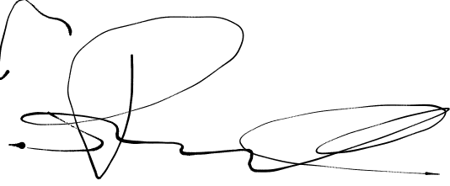  Group 3 | Meeting Log #4 | 2/6/2021 | 30 Minutes
Team Members | Dane Manley | GUI skeleton | 
Team Members | Santiago Ramirez | Git Organization
Team Members | Daniel Espinel | Git Management/Readme | 
Team Members | Anthony Peterson | First Meeting (N/A) | AP
Topics Discussed |  | - Status  - Merging our branches  - Other deliverables
Obstacles Encountered

Finished Items |  | - All operations other than load/store
Unfinished Items |  | - load/store  - Other deliverables
Notes

